The S3 bucket created

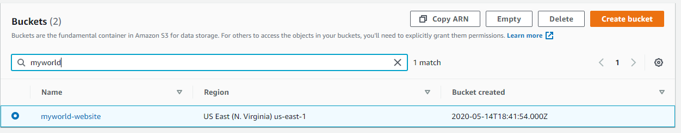

a screenshot showing all the website les uploaded to the newly created S3 bucket.

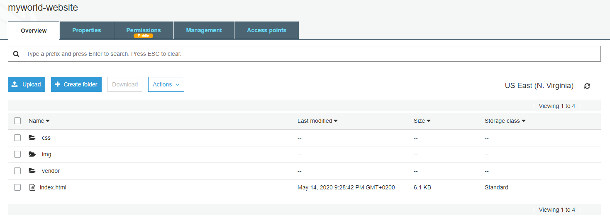

The S3 bucket is configured to support static website hosting.

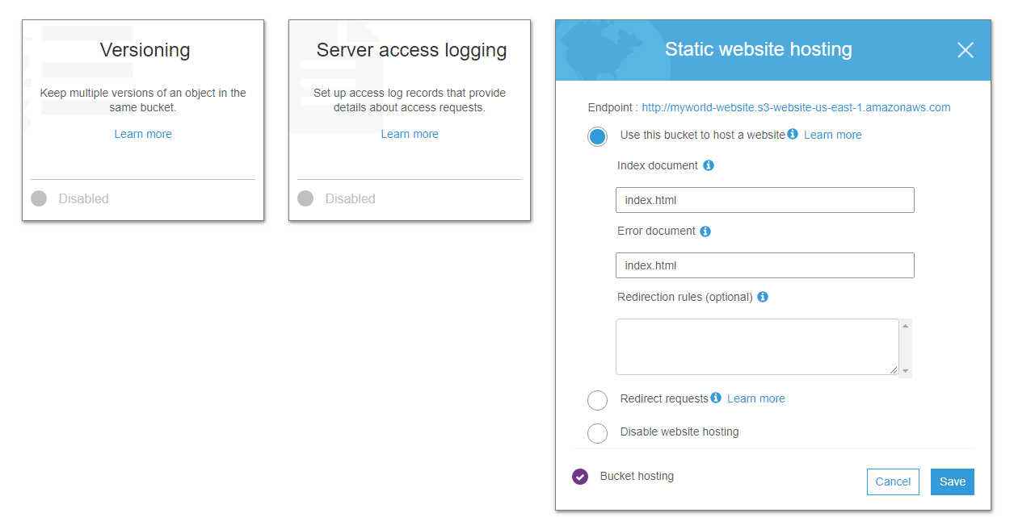

The S3 bucket has an IAM bucket policy that makes the bucket contents publicly accessible

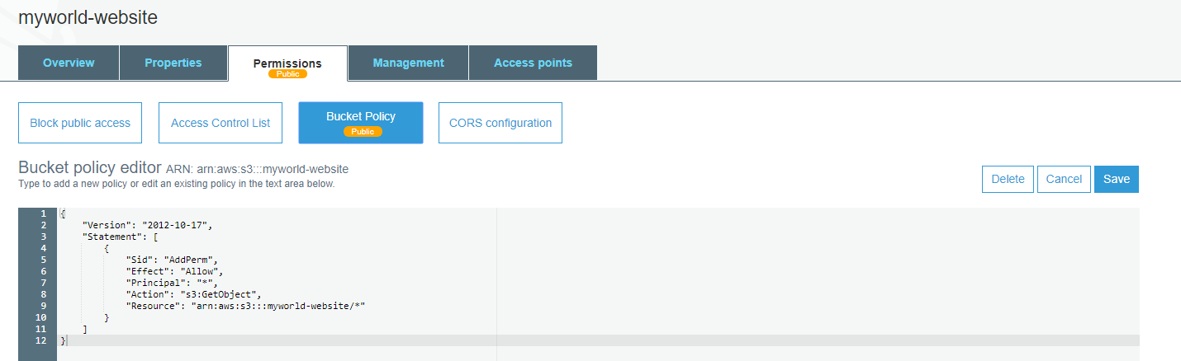

CloudFront has been configured to retrieve and distribute website less

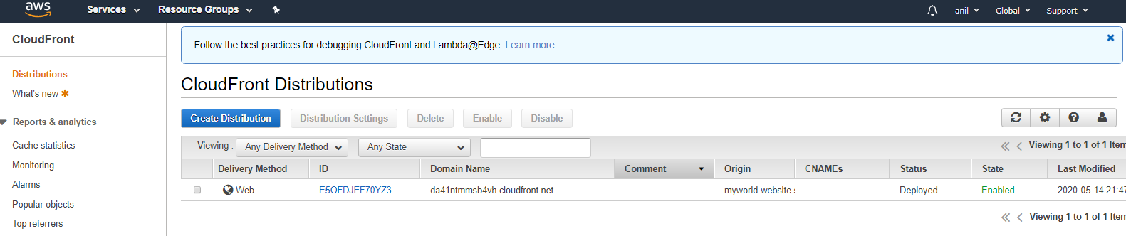

Webbrowser access:

<https://da41ntmmsb4vh.cloudfront.net/index.html>